Study Pod

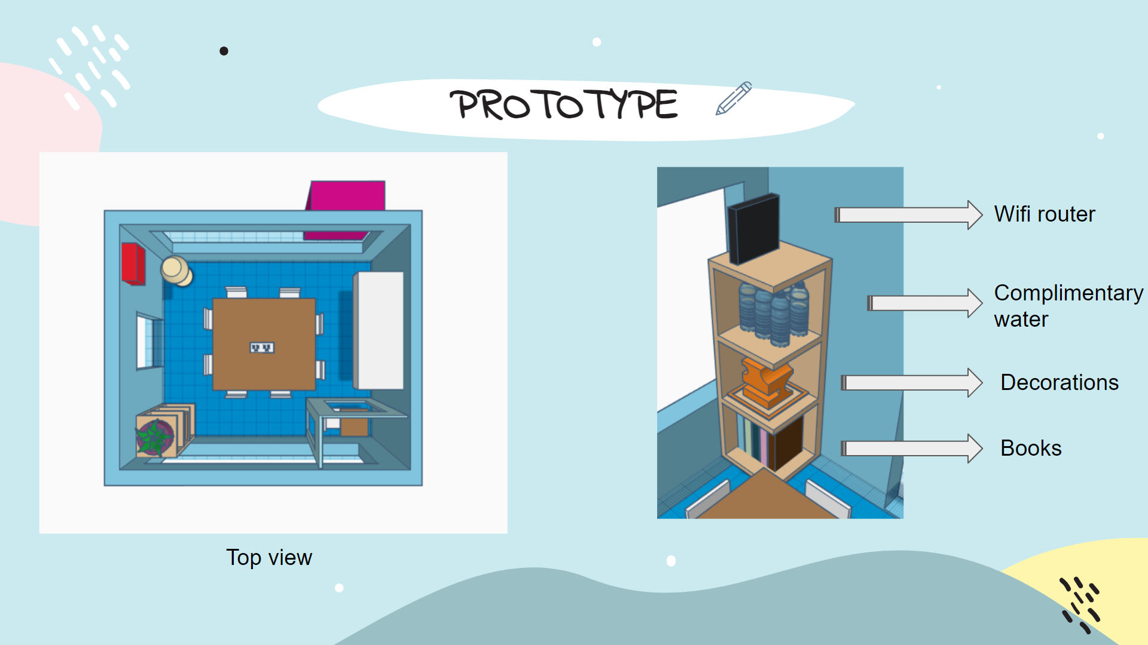

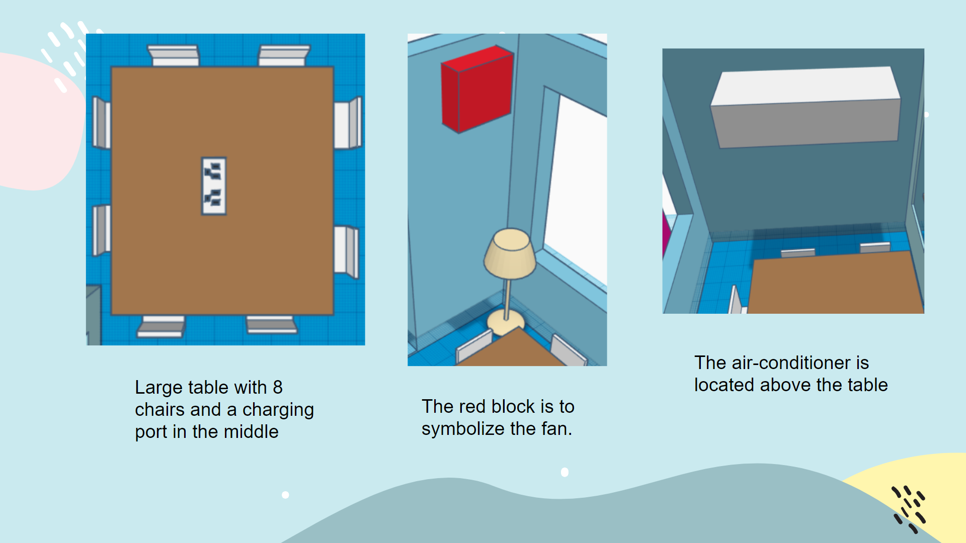

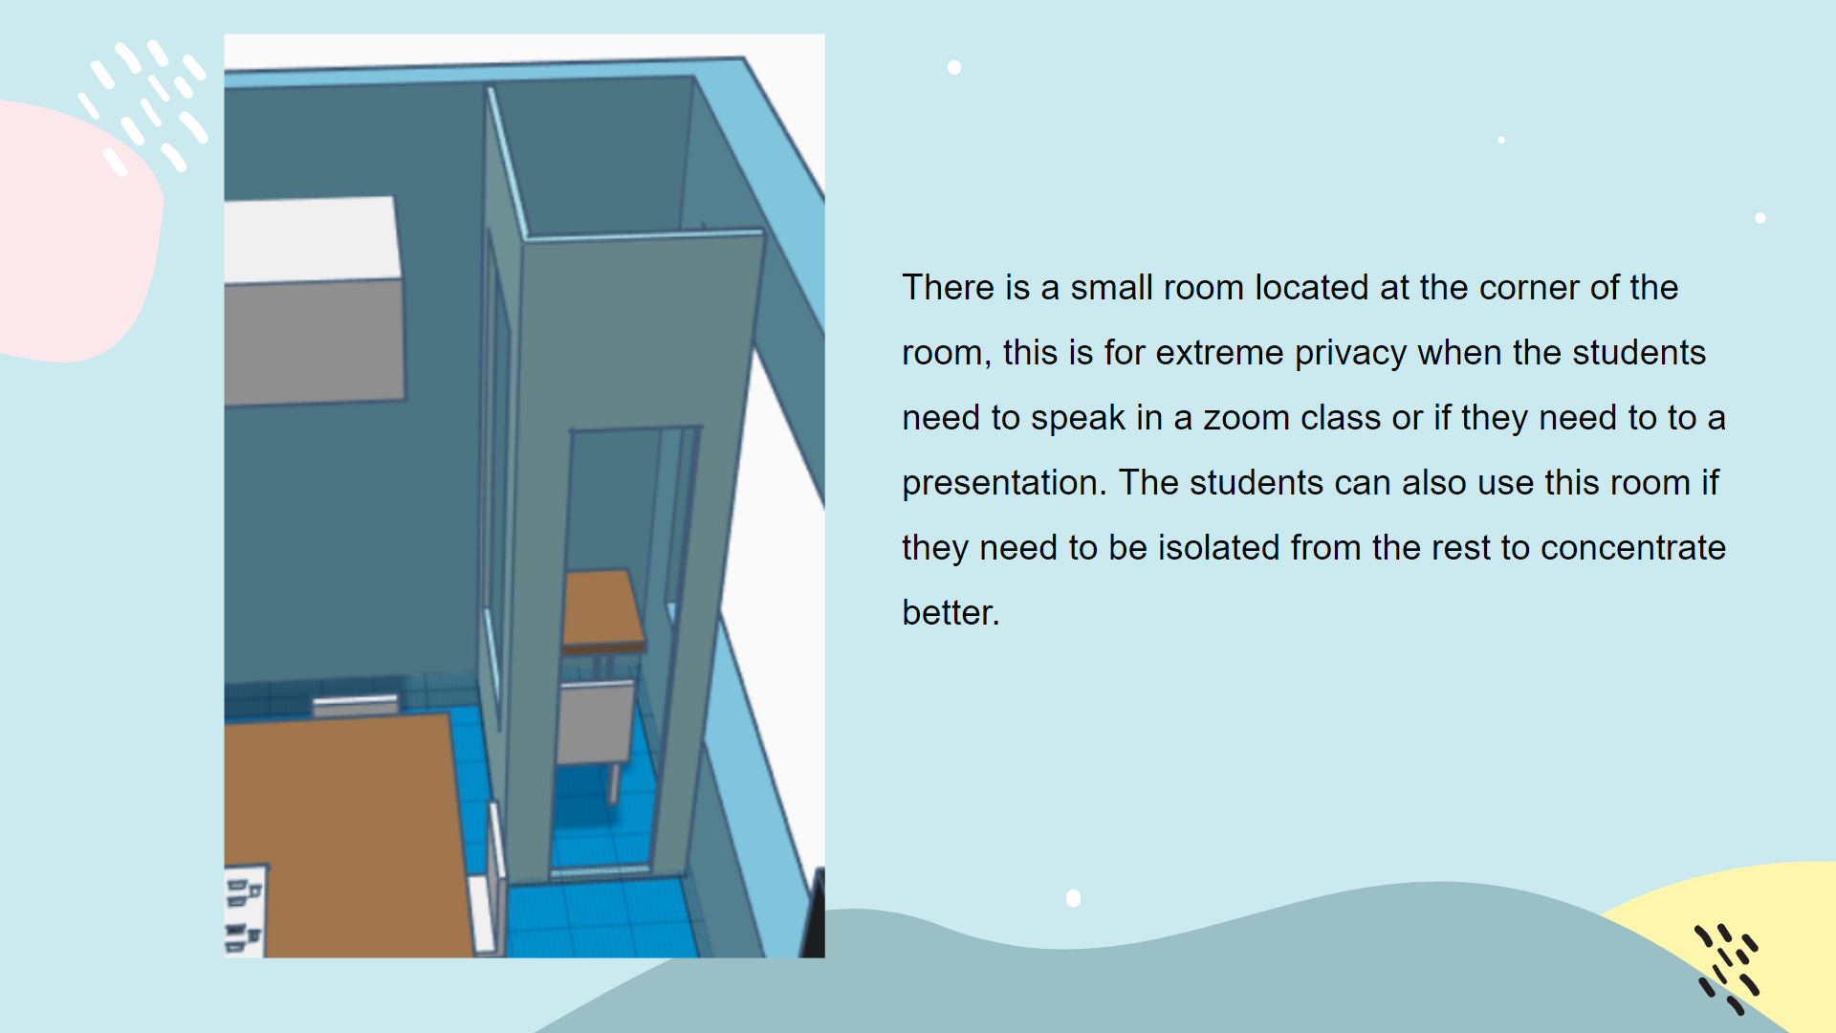

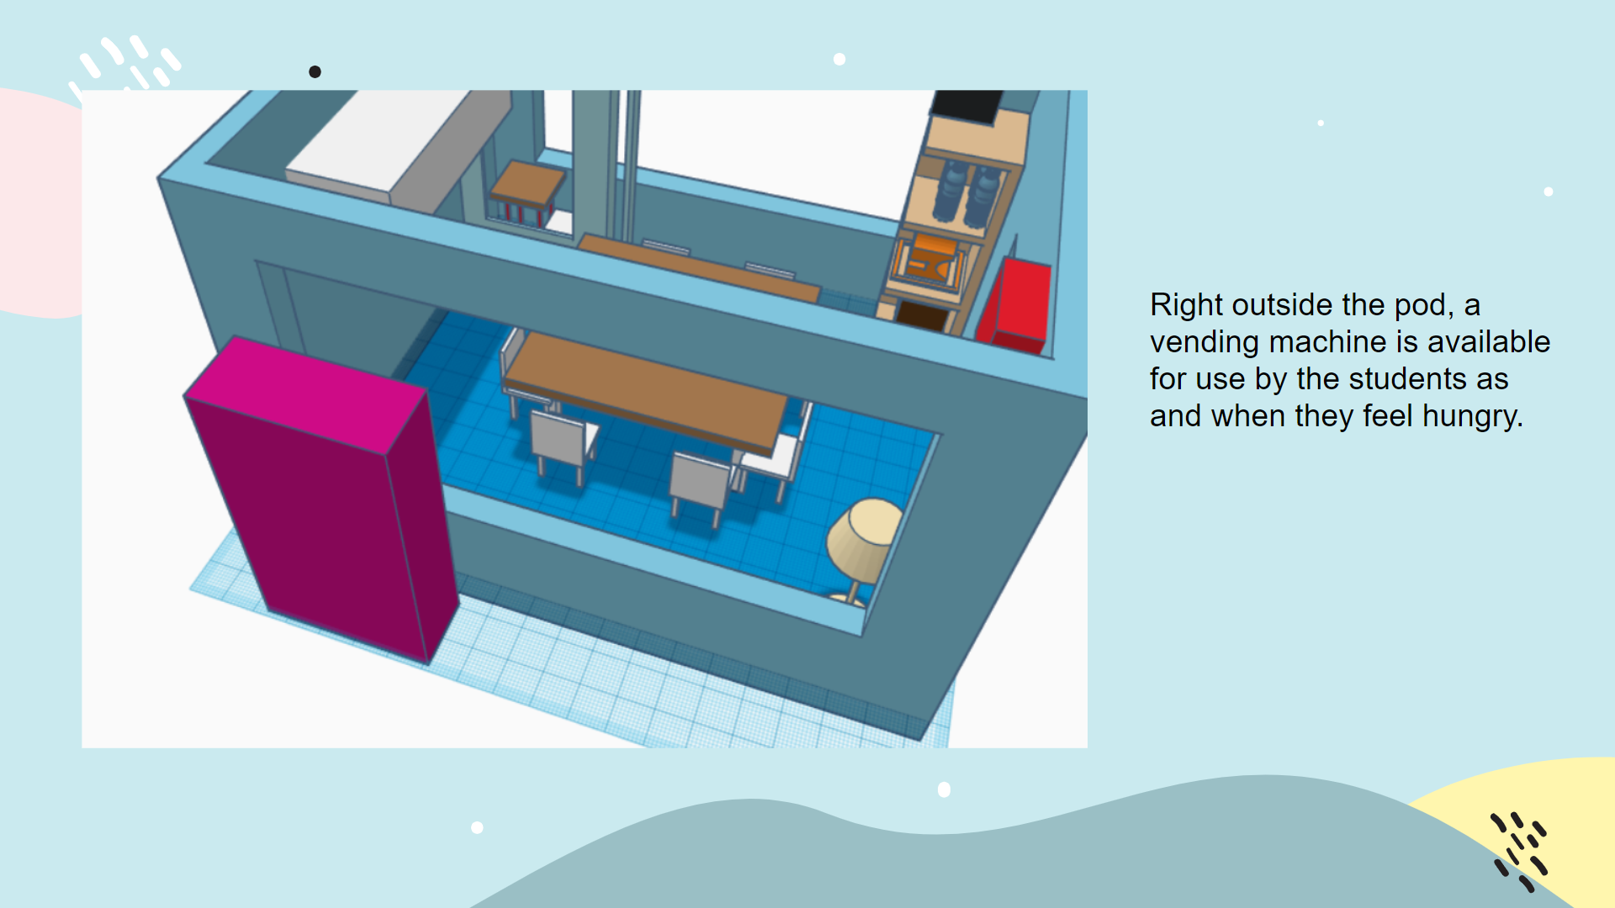

Marvel App - <https://marvelapp.com/prototype/bfg0e3g>

0. Sign In/ Sign Up

Users are greeted with a Sign in page. If the user does not have an account, the user can click on “do not have an account?” at the bottom and sign up from there.

**Order for Sign In:**

**[Sign In] → Sign In → [Home]**

1. Homepage

After signing in, users will be greeted with the home page with the apps feature. If the user were to click on the right side of the screen, it displays the classes for today. If the user click on the left side of the screen, it displays the profile section

**Order for Homepage:**

**[Home] → Right side → [Today’s Classes] → Left side → [HomePage] → Left side → [Profile]**

1. Profile

In the profile section, users can see his name, school, grades and goals. Users are able to add in goals to help motivate themselves to study harder.

**Order for Profile:**

**[Profile] → Grades → [Grades] → Go Back → Goals → [Goals] → Plus Icon → [Add Goals Page] → Plus Icon → [Grades] → Go Back → [Profile]**

1. TimeTable

When users click on TimeTable Function, they will be redirected to a page with many bars, each representing a day of the Weekday. The timetable of the user will already be prebuilt. Users can add slots to the timetable if necessary due to extra classes such as supplementary classes. (In this prototype, only Monday was shown to be edited). If users need to clear what they have edited, they can click on the rubbish bin icon.

**Order for TimeTable:**

**[Home] → Timetable → [Time Table] → Monday → [Add Slot] → Plus Icon → [Time Table] → Bin Icon → [Time Table] → Back Arrow → [Home]**

1. To Do List

When users click on the To Do List Function, they will be redirected to another page with a purple background. On default, there will be 2 pages available. Users can create tasks on the pages by clicking on the plus icon at the top right of the screen. When done with the tasks, Users can click on the boxes beside the tasks to check it. When adding tasks, Users will be redirected to another page to add the details of the item such as Name, Description, and Due Date for the item. Users can traverse to the next page items by clicking on the box at the bottom of the screen. Users can add tasks on different pages even if the first page is not filled, in the event they want to organise the tasks.

**Order for To-Do List:**

**[Home] → To-Do List → [First Page] → Plus Icon → [Add Task] → Add Button → [First Page] → Tick Check Box → [First Page] → Second Page →[Second Page] → Plus Icon → [Add Task] → Add Button [Second Page] → Back Arrow → [First Page] → Back Arrow → [Home]**

1. Lock Function

When a user uses the lock function of the app, the user must first specify the period the phone will be lock for. After specifying the time, the user can lock the whole phone until the timer runs down or if the user manually unlocks the lock by clicking “unlock”.

**Order for Lock Function:**

**[Home] → Lock Function → [Lock Function] → Choose a time → [Chosen Time Page] → Lock → [Confirmation Page] → Confirm → [Unlock Page] → Unlock → [Lock Page]**

1. Notes

When users click on the Notes Function, they will be redirected to another page. On default there will be 5 pages available, but users can add more if they want. Users can add items to the notes by clicking on the plus icon at the bottom right. When adding an item, the user will be redirected to another page to add details of the notes such as Name of Subject, Title, and Description. On default, there will be one note on the first page to give an example to the user of how an item will look like. Users have the option to click on each note to expand the notes so as to edit it or read it. Users can either click on the boxes at the bottom to traverse the pages, or click on the right side to go to the next page, or to the left sides to go back to the page before. This allows users to categorise the notes better and neater as they can categorise according to subjects, as shown in the prototype.

*Please note for the prototype, it was prototyped such that only Mathematics Fractions can be viewed and edited. Also, for each page, please add an item inside to ensure that the transition will be smooth.

**Order for Notes:**

**[Home] → Notes → [First Page] → Plus Icon → [Add item] → Add [First Page] → Fractions → [Fractions] → Edit Button → [Edited Fractions] → Thrash Icon / Back Arrow → [First Page] → Click Right Side/ Adjacent Bottom Circle → [Second Page] → Plus Icon → [Add Item] → Add → [Second Page] → Click Right Side/ Adjacent Bottom Circle → [Third Page] → Plus Icon → [Add Item] → Add → [Third Page] → Click Right Side/ Adjacent Bottom Circle → [Fourth Page] → Plus Icon → [Add Item] → Add → [Fourth Page] → Click Right Side/ Adjacent Bottom Circle → [Fifth Page] → Plus Icon → [Add Item] → Add → [Fifth Page] → Click Left Side/ Adjacent Bottom Circle X 4 → [First Page] → Back Arrow → [Home]**

1. Calendar

Users are also able to use the app’s calendar function to view the calendar. The calendar function in this case is unique because it is linked with the user’s TimeTable, Booking Time of the Study Pod, and the user’s To-Do List. Users can also add an item to the calendar. This makes it easier for users to plan and allows for better time management as they can view all the tasks they need to do and also see what plans they already have.

**Order for Calendar:**

**[Home] → Calendar → [Calendar] → View → [April 13] (Example without any events or booking time of the Study Pod) → Back Arrow → [Calendar] → 20 → [20 April] → View → [Items on 20 April](Assume a booking of the StudyPod was at that time) → Plus Icon → [Add Item] → Plus Icon → [Edited 20 April] → Back Arrow → [Calendar] → Cancel → [Home]**

1. Browser

The browser function is special because it filters out webpages based on words in a filtered list. The list can be seen in settings. Users can see the filtered out words but cannot edit them. The browser function is important to have especially when the lock function is active, because this will still allow users to surf the web for information. Users also can clear history in the settings function.

**Order for Browser:**

**[Home] → Browser → [Browser] → Search Icon → [y8.com] (Error due to filtered web page searched) → Search Icon → [Wikipedia] → Settings → [Settings] → View History → [History List] → Select y8 → [y8 selected] → Clear Selected [History List] → Clear All → [History List] → Back Arrow → [Settings] → Clear Cache → [Browser] → Back Arrow → [Home]**

1. Bookings

In Bookings, users will view the calendar for the month. For the dates that have been booked, the dates will be circled with a red circle. Users can click on the dates with a red circle and the timing of the booking of the Pod will be indicated below the date. Users can also click on “View” to get the QR code to scan at the Pod. Users can also click on a date and book for a slot of the pod. (It has been prototyped for 1-3pm). Users can also click on the wallet and add balance if necessary. After Confirmation of time, a QR code will be displayed to show confirmation of order.

**Order for Bookings:**

**[Home] → Bookings → [Bookings] → 18 → [Jan 18] → View → [QR Code] → Back Arrow → [Bookings] → 22 → [Jan 22] → Book → [Timings page] → 1300-1400 → [Chosen Timing Page] → 1400-1500 → [Chosen Timing Page] → Confirm → [QR Code] → OK → [Bookings] → 22 → [Jan 22] → View → [QR Code] → Back Arrow → [Bookings] → Ok → [Home]**

OR

**[Home] → Bookings → [Bookings] → 18 → [Jan 18] → View → [QR Code] → Back Arrow → [Bookings] → 22 → [Jan 22] → Book → [Timings page] → Wallet Icon → [Balance] → Plus Icon → [Enter Amount] → Tick Icon → [Balance] → Back Arrow → [Timings Page] → 1300-1400 → [Chosen Timing Page] → 1400-1500 → [Chosen Timing Page] → Confirm → [QR Code] → OK → [Bookings] → 22 → [Jan 22] → View → [QR Code] → Back Arrow → [Bookings] → Ok → [Home]**

1. Leaderboard

In Leaderboard, users can either create a league or join a league. After being in a league, users can click on the league names to look at the rankings in the league. The rankings are based on the total amount of points each user has. The point system is such that the user gains 10 points per hour locked. These points can then be redeemed for vending machine items or booking of study pod time. After purchasing vending machine items, users can click on rewards and view the QR code needed to redeem the items at the vending machine.

**[Home] → Leaderboard → [Leaderboard] → Create a League → [Create Page] → Tick Icon → [Leaderboard] → Join a League → [Join Page] → Join → [Leaderboard] → Redeem → [Redeems Page] → Vending Machine Items → [Redeem Vending Machine Items] → Drinks/Snacks → [Confirmation] → Confirm → [Leaderboard] → Rewards → [Rewards Page] → Click On Item Name → [QR Code] → Back Arrow → [Rewards Page] → Go Back → [Leaderboard] → Back Arrow → [Home]**

**[Home] → Leaderboard → [Leaderboard] → Create a League → [Create Page] → Tick Icon → [Leaderboard] → Join a League → [Join Page] → Join → [Leaderboard] → Redeem → [Redeems Page] → Study Pod Time → [Redeem Study Pod Time] → 1hr → [Confirmation] → Confirm → [Bookings] → 18→ [April 18] → Book → [Timings Page] → 1300-1400 → [Chosen Timings Page] → Confirm → [Bookings] → 18 → [April 18] → View → [QR Code] → Back Arrow → [Bookings] → Ok → [Leaderboard]**